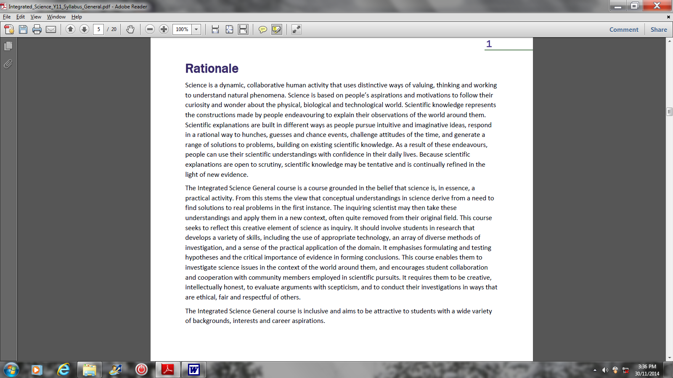
RATIONALE

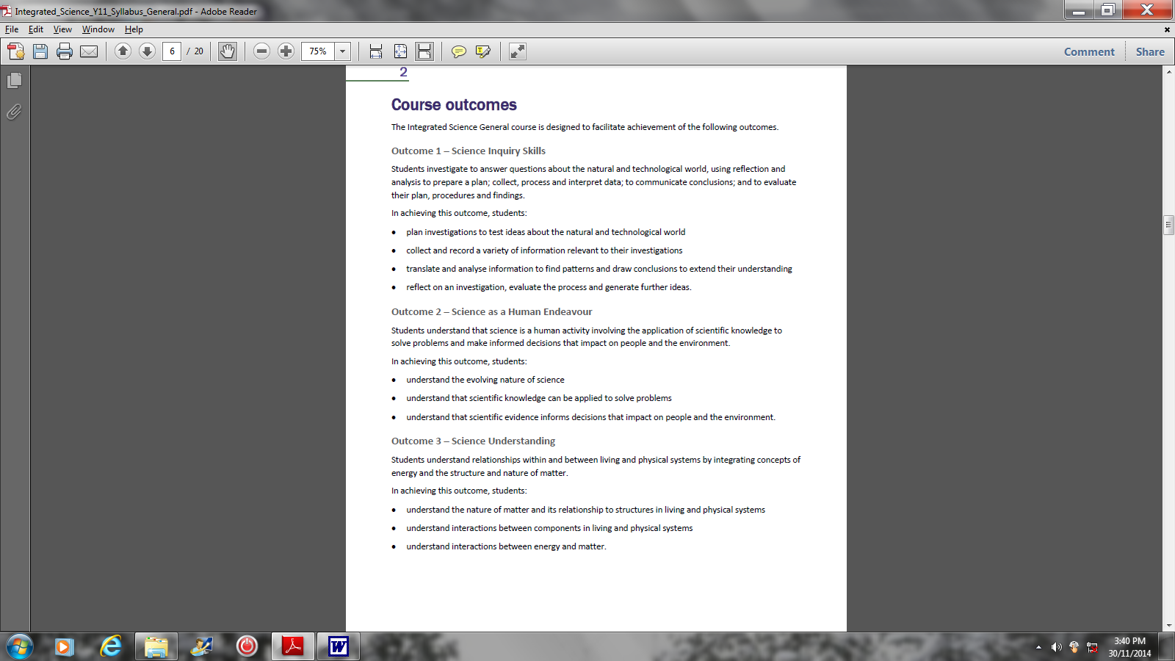
COURSE OUTCOMES

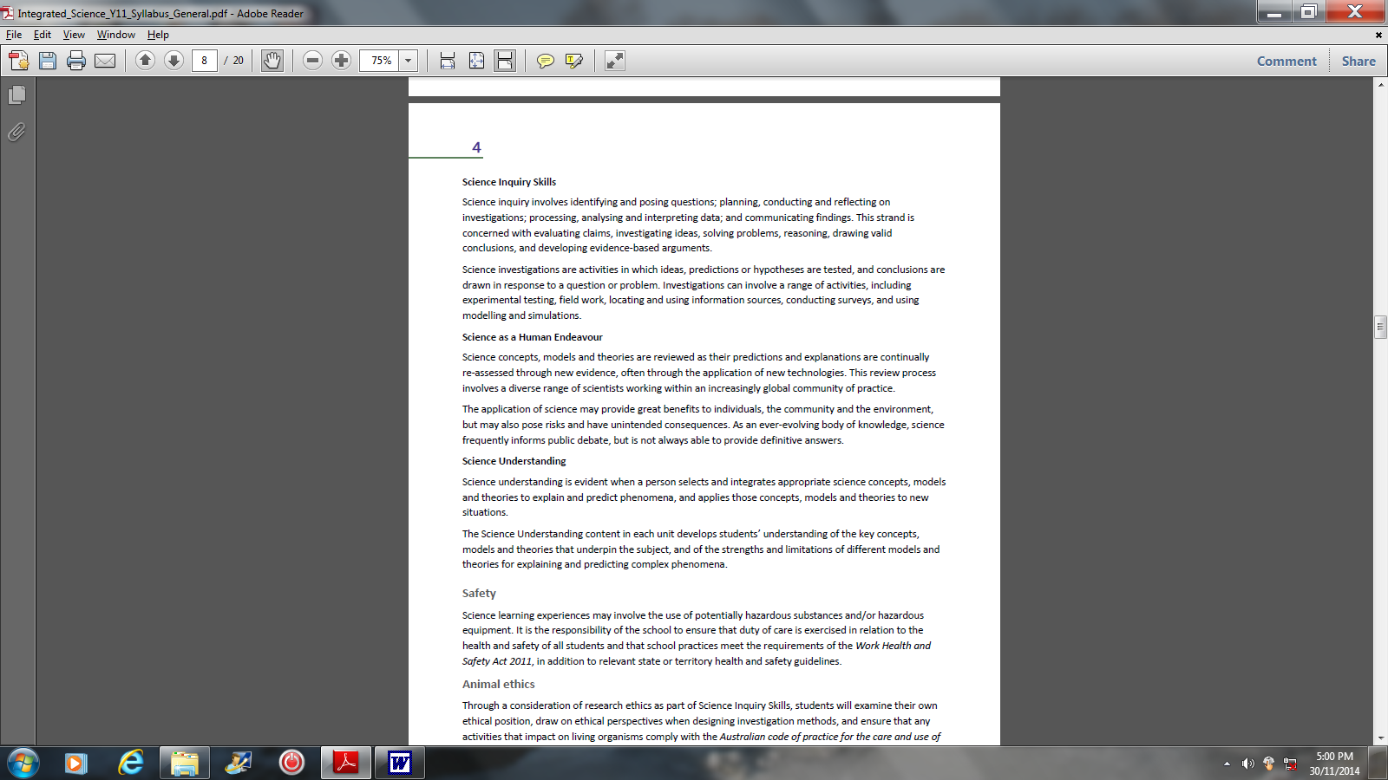

The year 12 syllabus is divided into two units, each of one semester duration.

Unit 3 emphasises earth and biological systems and focuses on the following topics:

- Interrelationships between earth systems,
- Structure and function of biological systems,
- Ecosystems and sustainability, and
- Species continuity and change.

Unit 4 emphasises physical and chemical systems and focuses on the following:

- Chemical reactions,
- Mixtures and solutions,
- Motion and forces, and
- Energy.

Unit 3 Description
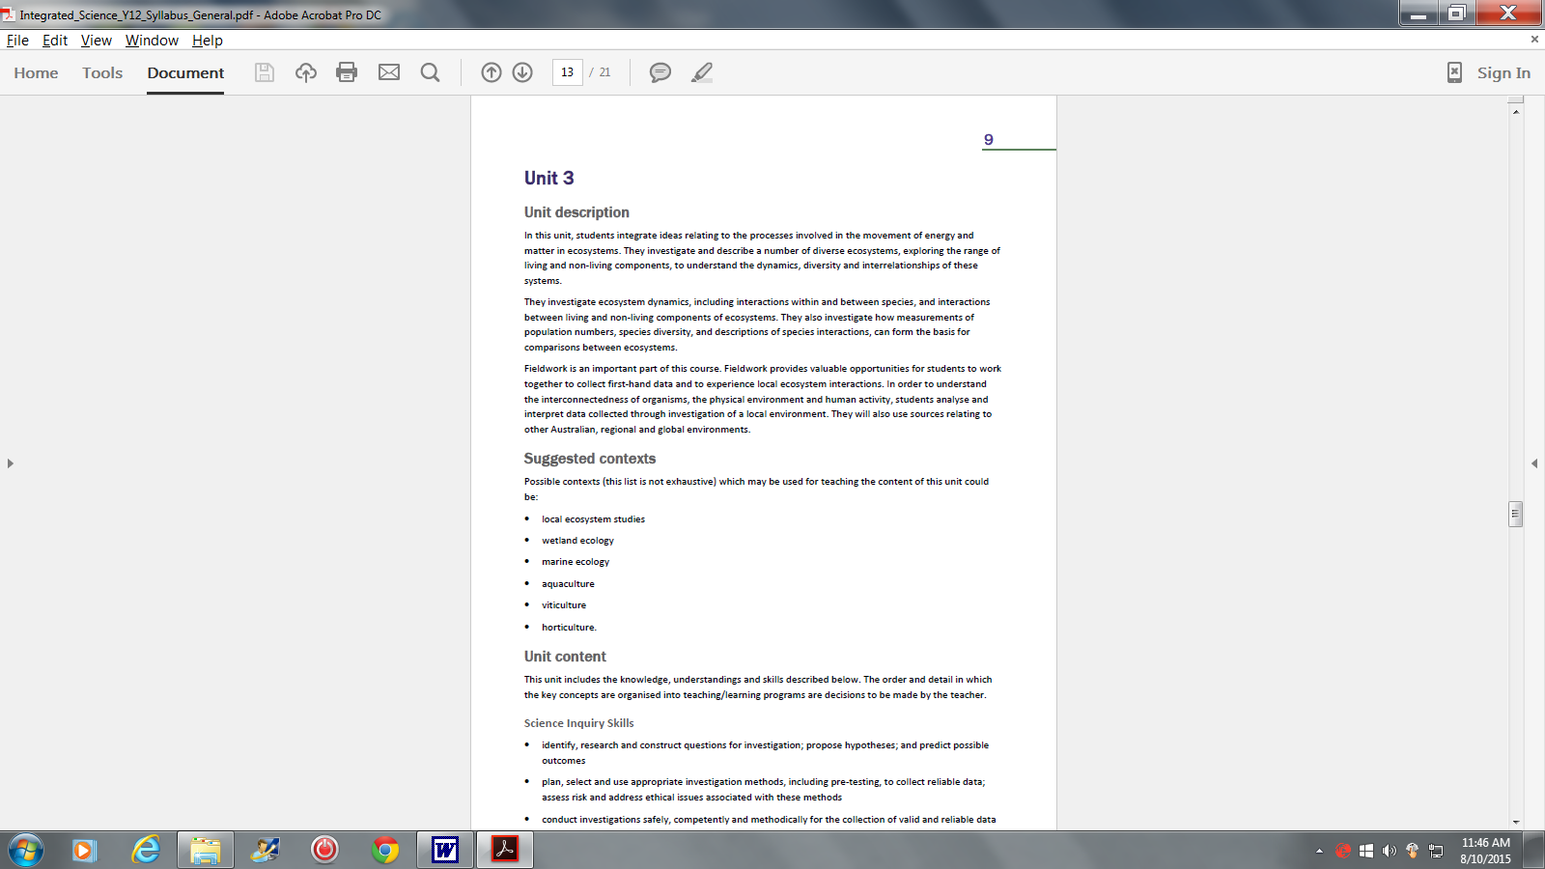

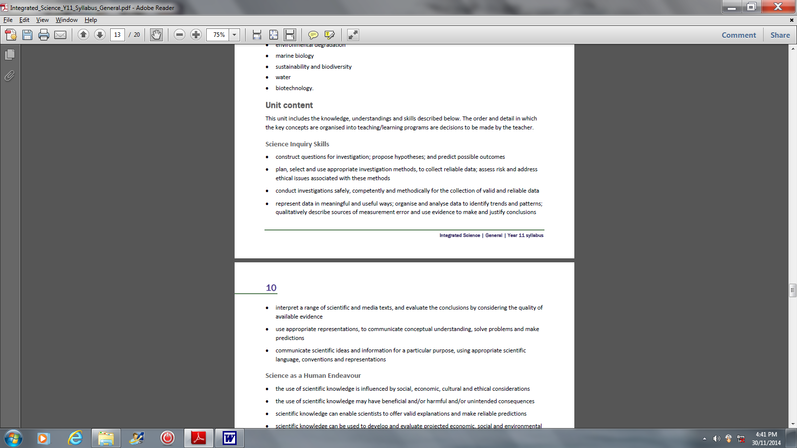
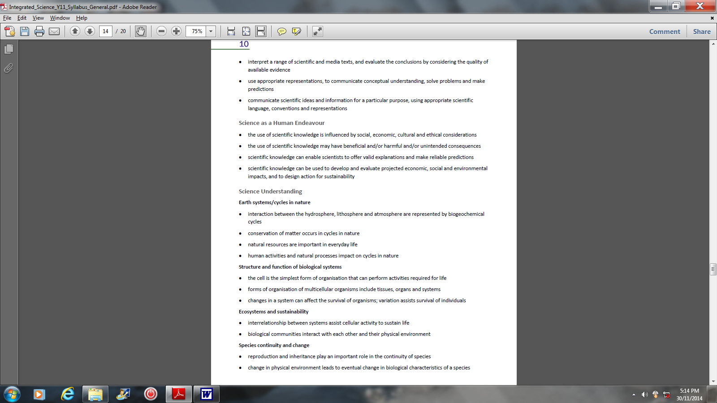
Unit 3 Content

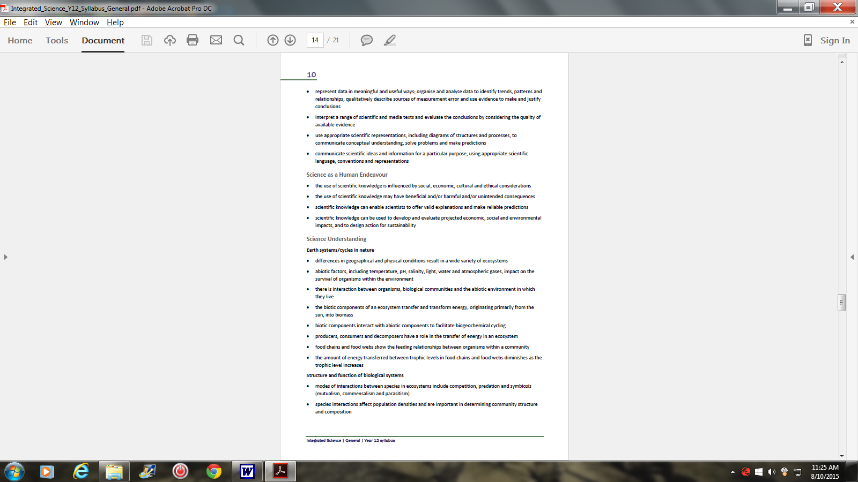
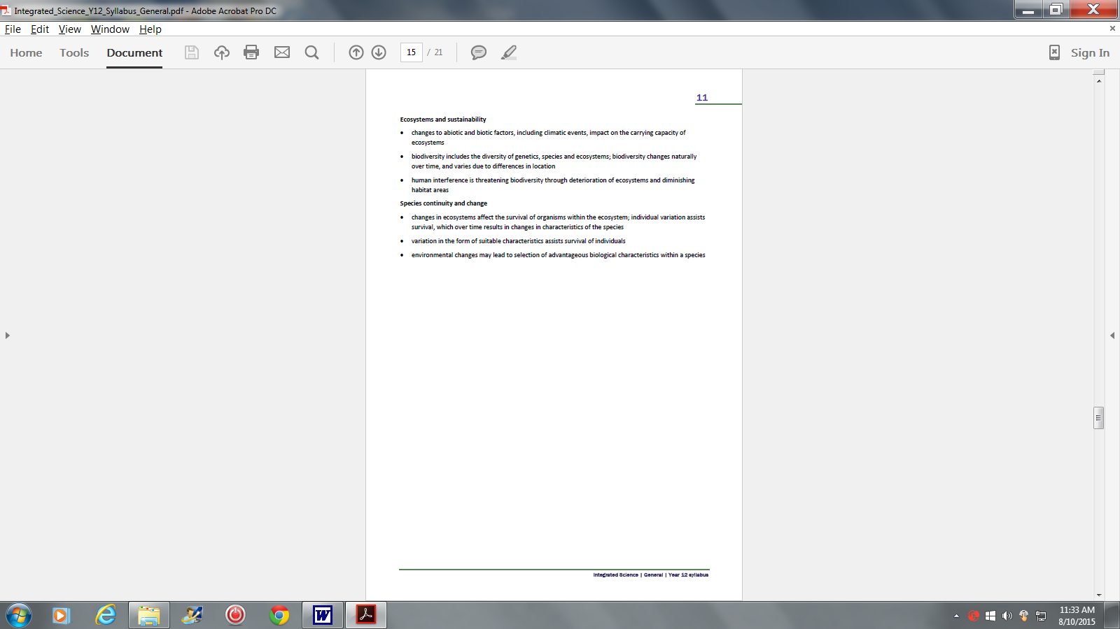

Unit 4 Description

Unit 4 Description

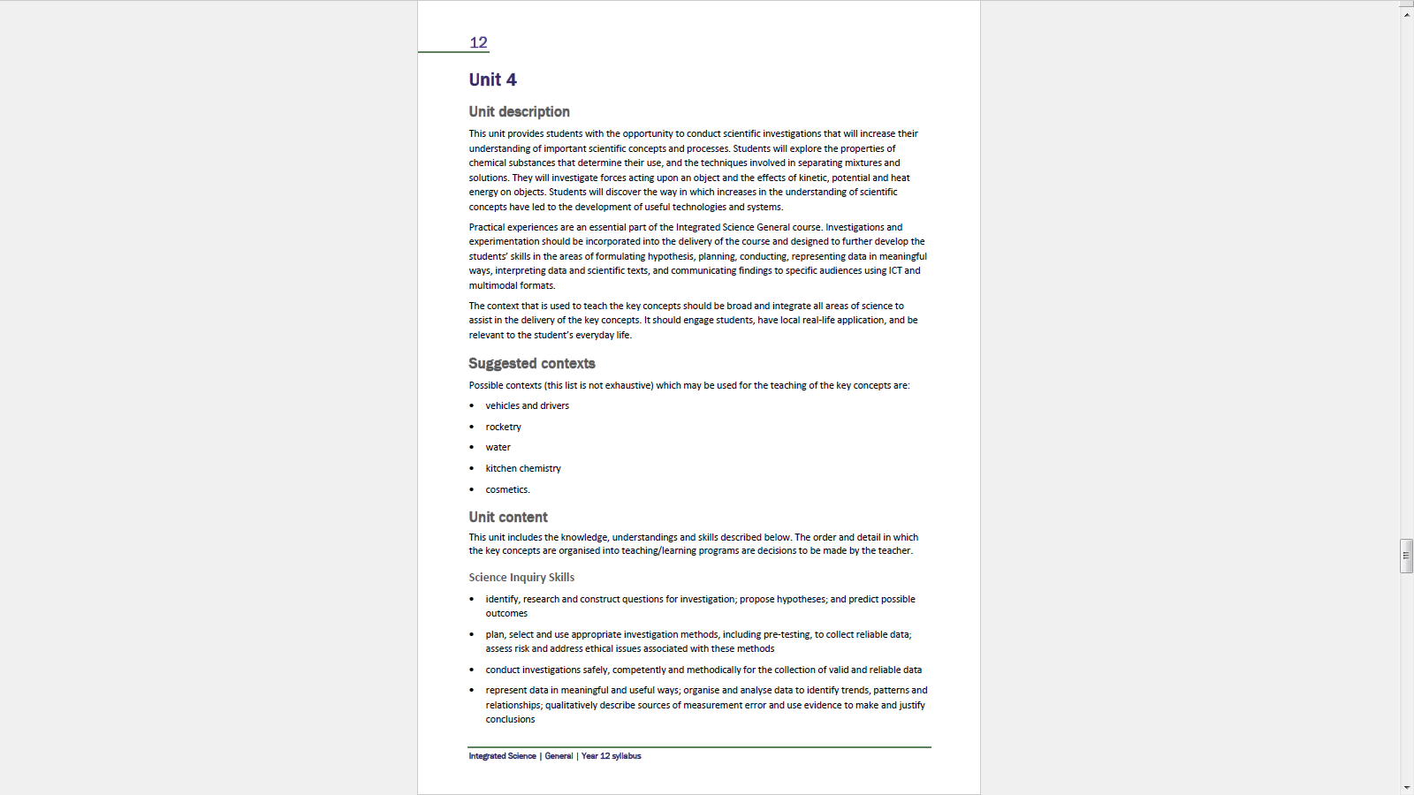

Unit 4 Content
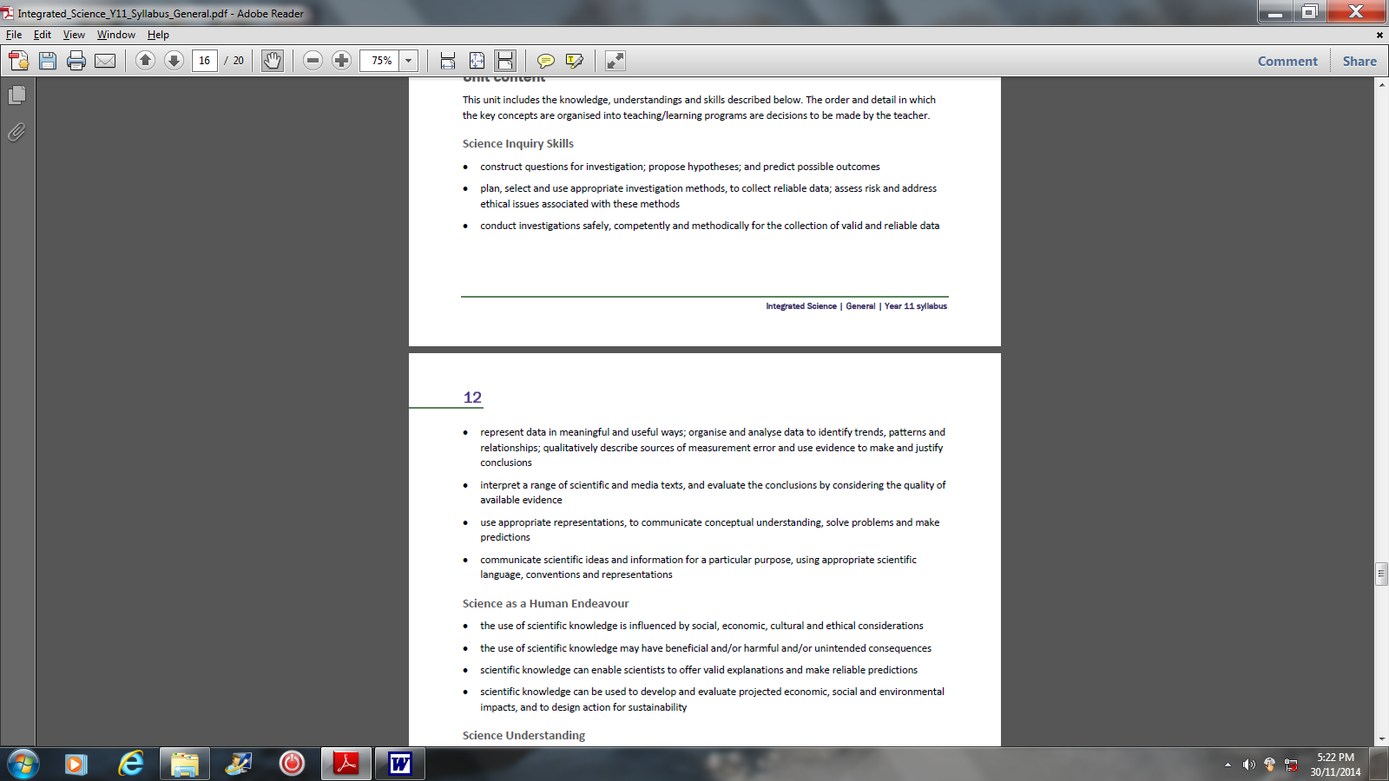

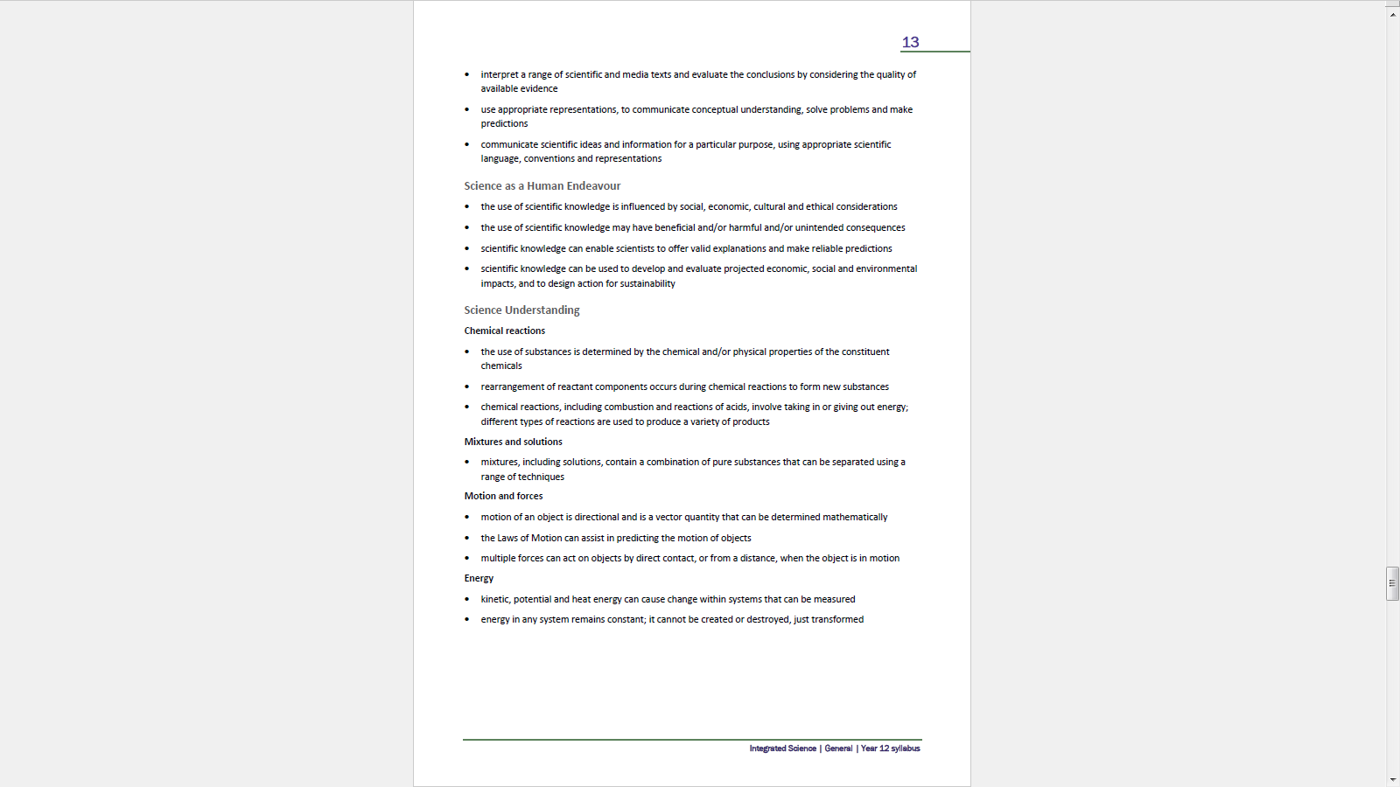

Week | CONTENT | Activities/ assessments
Week | TERM 4 | Activities/ assessments
1
2
3 | Scientific inquiry skills. Writing hypotheses; identifying variables; graphing continuous and discrete data; identifying sources of errors. | - Graphing continuous and discrete data.  - Writing hypotheses from available data.
4 | Local ecosystems – Characteristics (geographical & physical conditions).  Natural, urban, agricultural, aquacultural, freshwater and marine ecosystems.  Biodiversity – comparing terrestrial and aquatic ecosystems. | Excursion – Bull creek reserve
5 | Abiotic factors of a local ecosystem: water, light, temperature, pH, salinity.  Interaction with biotic and abiotic factors. Impact of abiotic factors on  survival of organisms living in that ecosystem.  Excursion to Brolga and Bullcreek | Task 1 – measuring abiotic factors of 2 aquatic ecosystems.
6 | Food chains – Energy transfer in a food chain. Source of energy.  Pyramids – numbers and biomass  Trophic levels and diminishing energy transfer. | Video – food chains and food webs
7 | Food webs – interlinking food chains.  Producers, consumers and decomposers in a food chain/web and their role in energy transfer. | Task 2 – effect of change in abiotic factors on a food web.
8 | Yr 12 Rollover start their holiday
9 | Yr 12 Rollover start their holiday
10 | Yr 12 Rollover start their holiday
 | TERM 1
1 | Horticulture – type of soils.  Microscopic and macroscopic structure & function of plants. Role of plants (salinity, nitrification, oxygenation, energy converters). Chemical equations involved. | Video – Leaves of green  Activity – stomata and xylem
2 | Seed structure(epigeal and hypogeal).  Deforestation and agriculture – effect on water table.  Use of fertilisers. Water pollution and eutrophication. | Task 3 – effect of salinity on plant growth
3 | Biogeochemical cycles – circulation of essential elements. | Video – nitrogen cycle
4 | Modes of interaction between species in an aquatic ecosystem(symbiosis; predation, mutualism, commensalism, parasitism).  Population density and its calculation of. Factors affecting it.  Effect of the interaction on community structure and composition. | Activity - measuring population density (capture/recapture).
5 | Biodiversity – genetic and species; biodiversity and location.  Urban sprawl and effect on biodiversity and ecosystem (extinction of  fauna and flora). | Task 4 – evaluation of information in a media text.
6 | Deterioration of ecosystems and diminishing of habitat areas.  Carrying capacity of ecosystems. (Amazon; acid rain – equation). | Activity – Amazon forest
7 | Genetic variation- sources; gene pool in a population.  Natural selection and survival of the fittest (Peppered moth). | Interactive activity on natural selection.
8 | Impact of natural selection on biodiversity. | Case study
9 | Adaptation – structural, functional and behavioural. | Video – adaptations  Activity – adaptation
10 | Adaptations of endemic species and invasive species. | Video – cane toad  Task 5– Test

Week | CONTENT | Activities/ assessments
Week | TERM 2 | Activities/ assessments
1 | Materials used in car manufacturing.  Chemical composition of materials used in car manufacturing.  Physical and chemical properties of these materials. | Task 7 – Research  Materials used in safety designs in vehicles
2 | Alloys – properties and uses.  Rubber – properties and uses.  Plastics – properties and uses. | Activity1 – alloys  Activity2 – plastics I & II
3 | EXAMS
4 | EXAMS | Task 6 – Test - SCASA
5 | Comparison of different fuels (alcohol, gas, diesel and petrol).  Chemical reactions – characteristics; reactants & products and energy | Task 8 – Investigation  Energy content
6 | Combustion reactions – word and chemical equations(balancing).  Rust formation – chemical equation (balancing).  Oxidation/reduction reactions in car battery. | Activity4 – rust and oxidation.  Video – rusting  Activity5 – converting oxidised metal back to metal
7 | Mixtures found in cars – petrol and alloys.  Separating mixtures using appropriate techniques. | Activity6 – separating alcohol from H₂O.
8 | Alcohol – chemical reaction in the body. Breakdown of alcohol in the body.  Effect of alcohol on body (nervous system).  Effect of various drugs on the nervous system. | Video – effect of alcohol on the body and the impact on drivers.
9 | Motion – Newton’s laws.  Reaction distance/braking distance. Worksheet. | Video – Newton’s laws  Activity7 – 1st, 2nd and 3rd Newton laws.
10 | Calculations – F = m x a  Application of Newton laws to vehicles and drivers. | Task 9 – Research  Role of alcohol in car crashes
 | TERM 3
1 | Speed Vs velocity.  Calculation of velocity.  Motion graphs(displacement versus time). | Activity8 – using ticker timer to calculate velocity.  Activity 9 – motion graphs1
2 | Acceleration – a function of velocity over time.  Acceleration problems | Activity 10 – using ticker timer to find acceleration
3 | Motion graphs of acceleration. Calculating displacement from motion graph, using the equation: S = V×t | Task 10 – Investigation  Factors affecting severity of collision  Hand in Task 9  Activity 11 – motion graphs2
4 | Forces – types (contact and non-contact)  Types of forces acting on a vehicle and the driver | Activity 12 – forces acting on objects  Validation test for Task 9
5 | Energy – types of energy (kinetic, potential and heat).  Calculations of kinetic and potential energies. | Activity 13 – types of energy
6 | Techniques and equipment used to measure types of energy.  Examples of kinetic, potential heat energy in vehicles. | Hand in Task 10
7 | Law of conservation of energy | Activity 14 – energy conservation  Validation test for Task 10
8 | Energy transformations in vehicles. | Activity 14 – energy transformations.
9 | EXAMS | Task 11 – Test (done during exam time)
10 | EXAMS

ASSESSMENT

Type of assessment | Weighting
Science Inquiry  Science inquiry involves identifying and posing questions; planning, conducting and reflecting on investigations; processing, analysing and interpreting data; and communicating findings. Students evaluate claims, investigate ideas, solve problems, reason, draw valid conclusions, and/or develop evidence-based arguments.  Science inquiry: Practical  Practical work can involve a range of activities, such as practical tests; modelling and simulations; qualitative and/or quantitative analysis of second-hand data; and/or brief summaries of practical activities.  Science Inquiry: Investigation  Investigations are more extensive activities, which can include experimental testing; conducting surveys; and/or comprehensive scientific reports. | 40%
Extended Response  Tasks requiring an extended response can involve: selecting and integrating appropriate science concepts, models and theories to explain and predict phenomena, and applying those concepts, models and theories to new situations; interpreting scientific and/or media texts and evaluating processes, claims and conclusions by considering the quality of available evidence; and using reasoning to construct scientific arguments.  Assessment may take the form of answers to specific questions based on individual research; exercises requiring analysis and interpretation and evaluation of information in scientific journals, media texts and/or advertising. | 30%
Test  Tests typically consist of multiple-choice questions and questions requiring short and extended answers. Tests should be designed so that students can apply their understanding and skills in the Integrated Science General course. | 15%
Externally set task  A written task or item or set of items of one-hour duration developed by School Curriculum and Standards Authority and administered by the school. | 15%

GRADING

A | Science Inquiry Skills  - Formulates an hypothesis, independently plans an investigation and identifies and controls relevant variables.  - Collects data and selects an appropriate format to organise and present data effectively.  - Uses evidence to draw inferences and conclusions that either supports or refute the stated hypothesis, and writes detailed scientific reports of investigations.  - Chooses correct formulae to perform accurate calculations, providing evidence of working and correct use of units.
A | Science Understanding and Science as a Human Endeavour  - Applies scientific principles, laws and/or concepts, and provides detailed and accurate explanations.  - Explains the cause of the problems, and analyses the merit of different approaches to solving problems.
B | Science Inquiry Skills  - Formulates an hypothesis, plans an investigation and identifies the relevant variables.  - Collects data, selects an appropriate format, and presents data accurately in most instances.  - Draws inferences and conclusions that relate to the stated hypothesis, and writes general scientific reports of investigations.
B | Science Understanding and Science as a Human Endeavour  - Applies scientific principles, laws and/or concepts and provides mostly accurate general explanations.  - Explains the cause of problems and their impacts, and discusses possible solutions.
C | Science Inquiry Skills  - Writes an hypothesis, with support, to plan an investigation, and identifies some of the controlled variables.  - Collects, organises and presents data with some inaccuracies; for example, uses the wrong type of graph.  - Makes simples inferences based on trends in the data, and writes general reports of investigations.  - Uses simple formulae to perform calculations, and provides some working to obtain an answer.
C | Science Understanding and Science as a Human Endeavour  - Identifies some scientific principles, laws and/or concepts; usually provides general explanations.  - Identifies the cause of problems; describes their impacts and provides a solution.

D | Science Inquiry Skills  - Writes an illogical hypothesis and identifies few, if any, of the relevant variables for an investigation.  - Collects and presents data, but with major limitations.  - Comments on data, but writes incomplete reports.  - Substitutes values into practiced formulae to perform simple calculations.
D | Science Understanding and Science as a Human Endeavour  - Does not use scientific principles, laws and/or concepts to support explanations.  - Identifies the cause of problems and offers a possible solution.
E | Science Inquiry Skills  - Rarely writes an hypothesis when presented with a problem to solve, and inaccurately identifies the relevant variables.  - Rarely collects, organises or presents data.  - Seldom comments on data or writes scientific reports.  - Answer is unreasonable. Confuses units or does not use units.
E | Science Understanding and Science as a Human Endeavour  - Recalls scientific principles, laws and/or concepts inaccurately and provides incorrect explanations.  - Gives incorrect reasons for the cause of problems, or makes no references to data.

